**Guest Amenities Program**

The objective it is to delight and surprise the guest when they stay with us.

We want to look after the guests that return to us so that they keep returning to us.

We want them to feel special, every time they come to stay with us we want them to feel like we knew that they are coming and this is their second home.

|  |  |
| --- | --- |
| ***VIP STATUS*** |  |
|  |  |
| VIP 1 | Very Important Guest |
| VIP 2 | Anniversary Card and House Wine |
| VIP 3 | Birthday Card and Birthday Plate |
| VIP 4 | Complaint Guest |
| VIP 5 | GC rewards Member |
| VIP 6 | Return Guest |
| No Show | Guest did not turn up |
| BTP | Business Travel Partner |
| BLACK | Black listed Guest |

If Reservation or Front Office pick up that a guest staying a lot more frequently Front Office to reassess the VIP Status for example is a guest reaches 100 stays FOM & Reservation Manager to upgrade VIP status from VIP 6 to VIP 1.

**Very important Guest** – This guest could be our AGM or one of our directors or a very regular guest that stays with us on multiple conversations. **Card, Wine, Sparkling and Still Water, Dressing Gown, Slippers**

**Anniversary** – Guest will call or let us know it is their Anniversary - **Card and Wine, Sparkling and Still Water, Dressing Gown, Slippers**

**Birthday** - Any guest that mention that it is their birthday or they are her celebrating their Birthday – **Birthday Card and Chocolate Plate, Sparkling and Still Water, Dressing Gown, Slippers**

**Complaint Guest** – Guest is returning after having a bad experience with us. - **Card and Wine. Sparkling and Still Water, Dressing Gown, Slippers**

**GC Rewards Guest** – These guests have signed up to be part of our Grand Chancellor Rewards Club

**Business Travel Partner** – This indicates their business has signed up to received contracted rates with HGCM

**Return Guest –** All return guest are to receive **Card, Sparkling and Still Water, Dressing Gown, Slippers.** Every 5,10,15,20 & 25 stays Front Office will arrange different amenities then will move to 50,75 & 100 amenities which will be larger and more rewarding the higher the return. **Return guest from 5 stays onwards will receive chocolates along with other items above.**

If a Guest has returned, we are required to give him a singed letter from Michelle on arrival, this will ask them multiple questions that will help us to make their stay a more enjoyable. On return you will need to update their profile in HMS to reflect what these states so that they can receive any request on their return stays.

If a guest declined being signed up to GC rewards to will need to add “DECLINED” to the folio.

Select the three dots next to the guest name

Once a pop sreen appers select edit

You will then see another pop screen, you will need to select “Personal/Preference” (Tab two)

From here you will see Loyalty card.

Right click in the blue loyalty card box

Once added to can press next to save this.

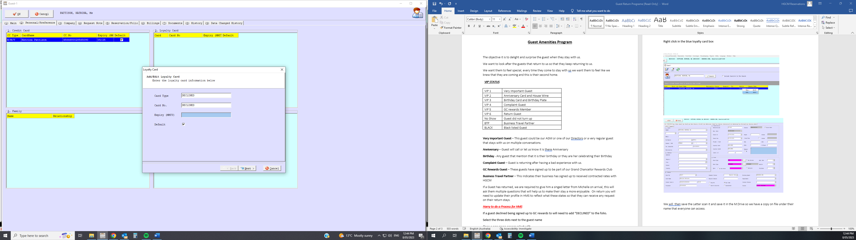

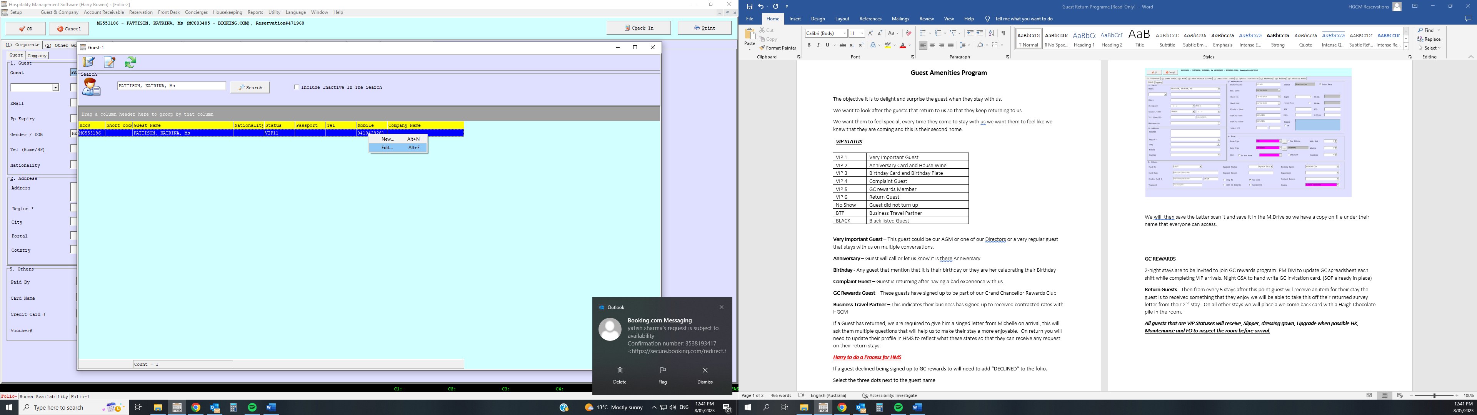

Once declined is added to the loyalty box you will also need to add a note under tab six “Special Instruction” this is to advise if a guest has been offered GC rewards or declined the offer.

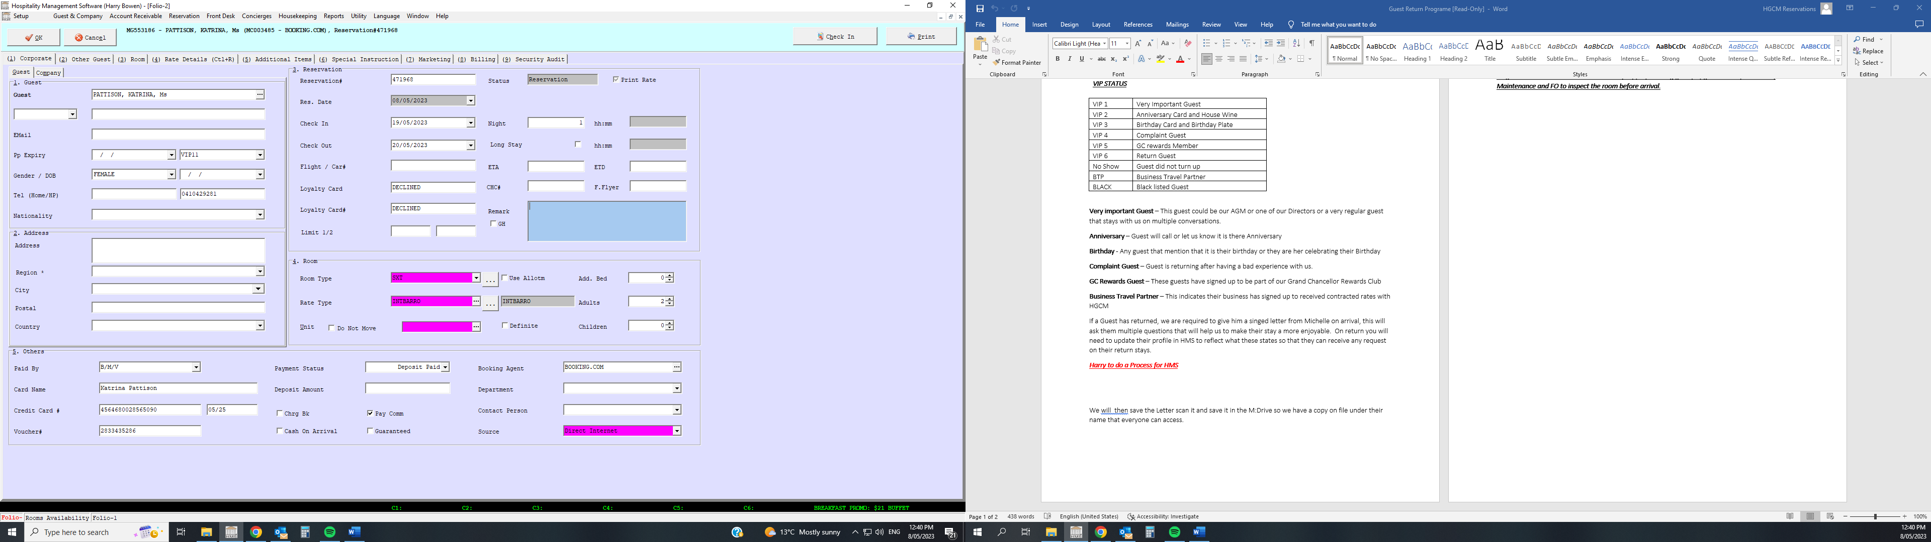

Once declined is added to the loyalty box you will also need to add a note under tab six “Special Instruction” this is to advise if a guest has been offered GC rewards or declined the offer.

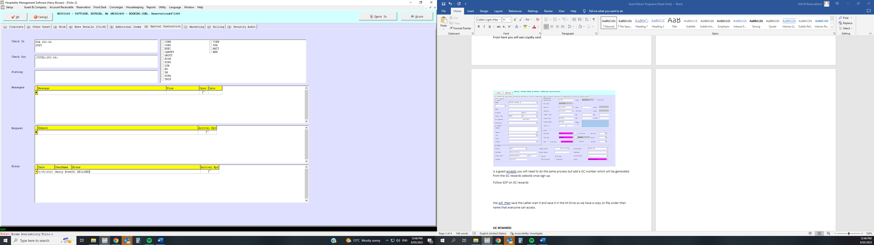

Is a guest is accepting you will need to do the same process but add a GC number which will be generated from the GC rewards website once sign up.

Follow SOP on GC rewards

We will then save the Letter scan it and save it in the M: Drive so we have a copy on file under their name that everyone can access.

**GC REWARDS**

2-night stays are to be invited to join GC rewards program. PM DM to update GC spreadsheet each shift while completing VIP arrivals. Night GSA to hand write GC invitation card. (SOP already in place)

**Return Guests -** Then from every 5 stays after this point guest will receive an item for their stay the guest is to received something that they enjoy we will be able to take this off their returned survey letter from their 2nd stay. On all other stays we will place a welcome back card with a Haigh Chocolate pile in the room.

***All guests that are VIP Statuses will receive, Slipper, dressing gown, Upgrade when possible.HK, Maintenance and FO to inspect the room before arrival.***